Fact Table –

|  |
| --- |
| EmpID |
| Age_ID |
| AgeGroup_ID |
| Attrition_ID |
| BusinessTravel_ID |
| Department_ID |
| Education_ID |
| EducationField_ID |
| EnvironmentSatisfaction_ID |
| Gender_ID |
| JobInvolvement_ID |
| JobLevel_ID |
| JobRole_ID |
| JobSatisfaction_ID |
| MaritalStatus_ID |
| Over18_ID |
| OverTime_ID |
| PerformanceRating_ID |
| RelationshipSatisfaction_ID |
| StockOptionLevel_ID |
| WorkLifeBalance_ID |
| TotalWorkingYears_ID |
| TrainingTimesLastYear |
| YearsInCurrentRole_ID |
| YearsSinceLastPromotion_ID |
| YearsWithCurrManager_ID |
| DailyRate |
| DistanceFromHomeInKm |
| EmployeeCount |
| EmployeeNumber |
| HourlyRate |
| MonthlyIncome |
| SalarySlab |
| MonthlyRate |
| PercentSalaryHike |
| StandardHours |
| NumCompaniesWorked |

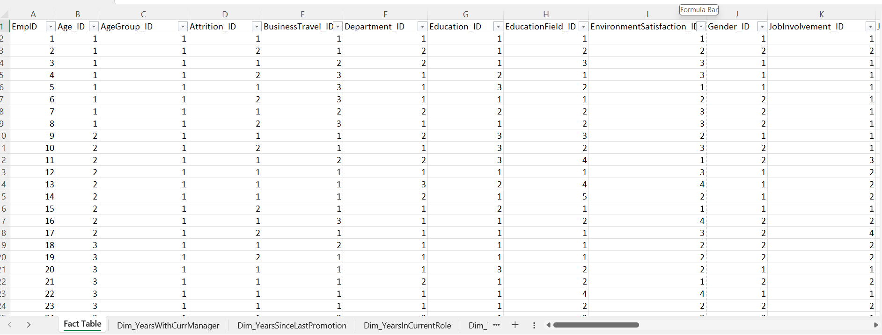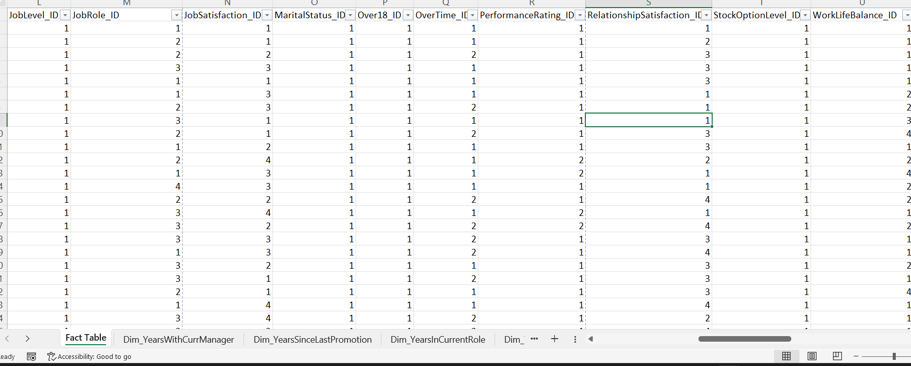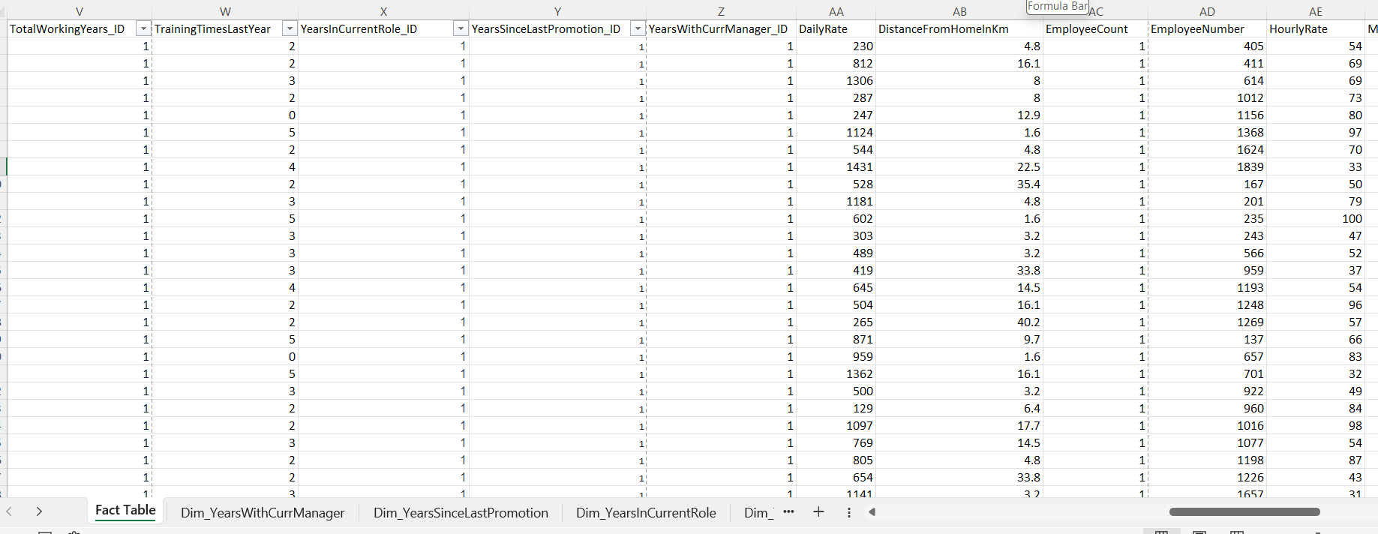

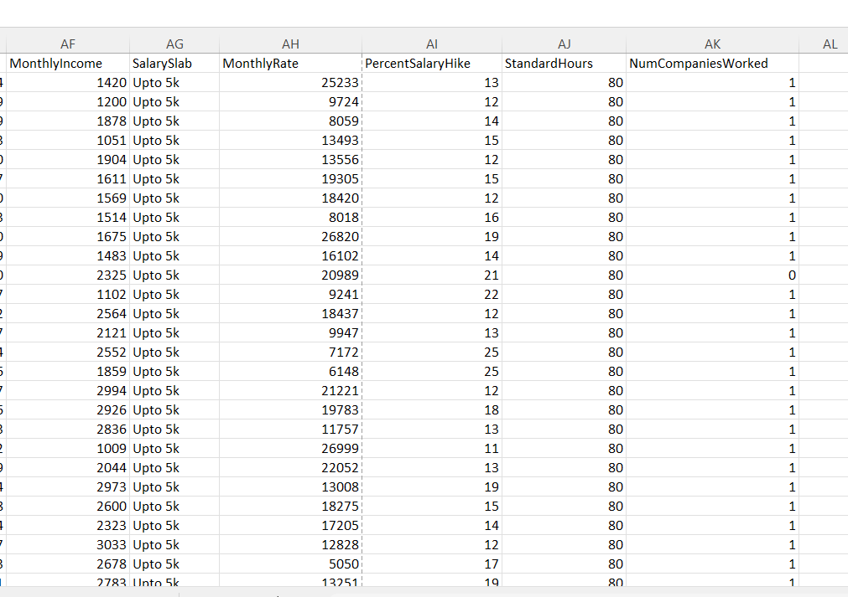

Dimension Table -

Dim_YearsWithCurrManager –

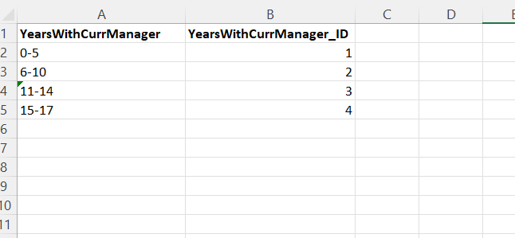

Dim_YearsSinceLastPromotion

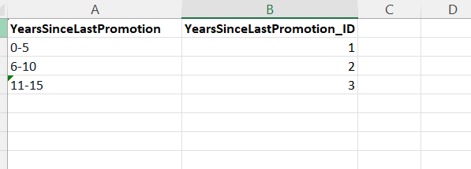

Dim_YearsInCurrentRole

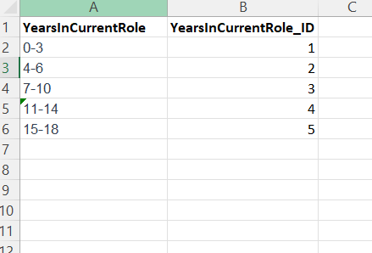

Dim_TotalWorkingYears

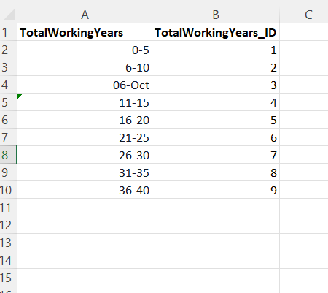

Dim_Emp

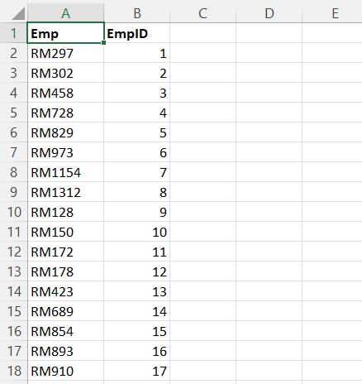

Dim_WorkLifeBalance

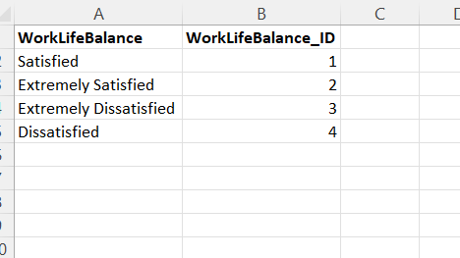

Dim_StockOptionLevel

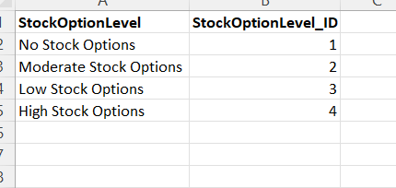

Dim_RelationshipSatisfaction

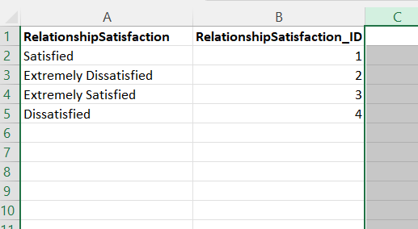

Dim_PerformanceRating

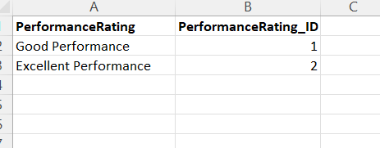

Dim_OverTime

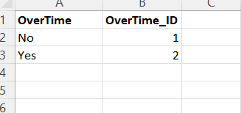

Dim_MaritalStatus

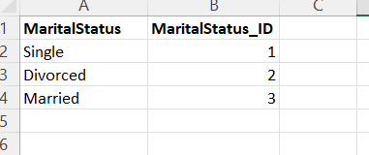

Dim_Over18

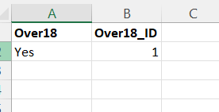

Dim_JobSatisfaction

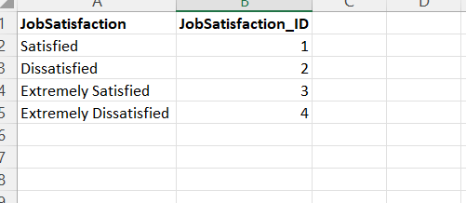

Dim_JobRole

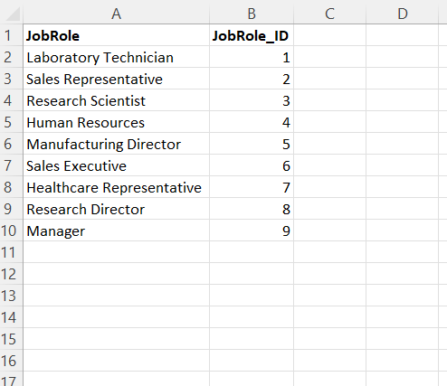

Dim_JobLevel

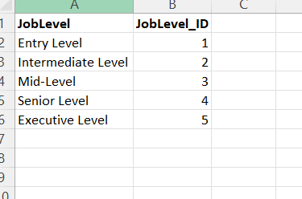

Dim_JobInvolvement

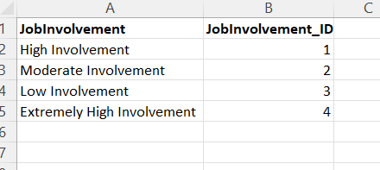

Dim_Gender

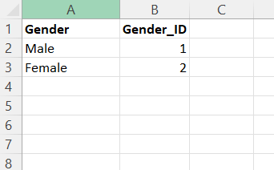

Dim_EnvironmentSatisfaction

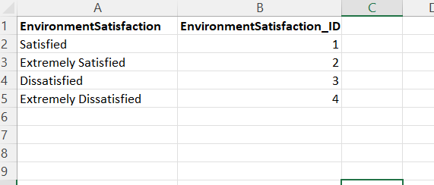

Dim_EducationField

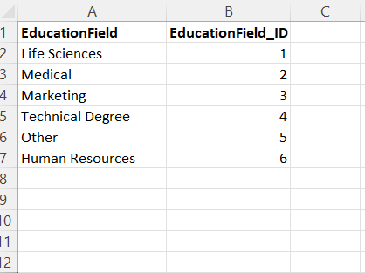

Dim_Education

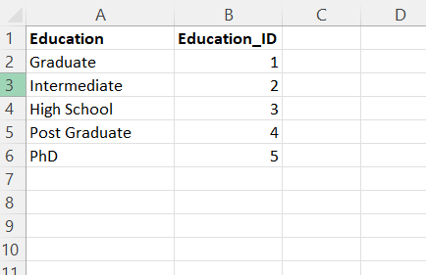

Dim_Department

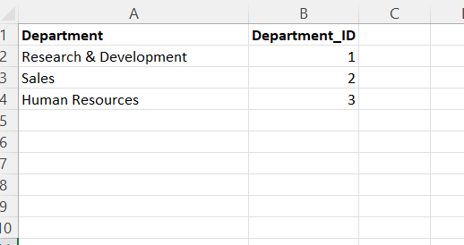

Dim_BusinessTravel

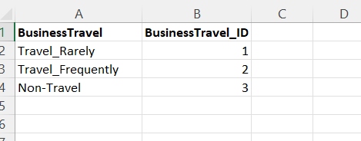

Dim_Attrition

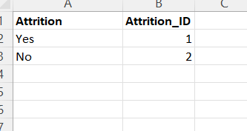

Dim_AgeGroup

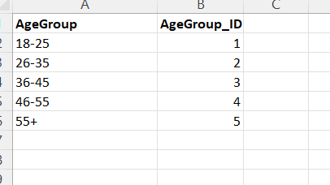

Dim_Age

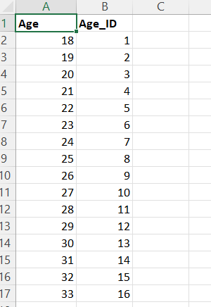

Schema –

